
Norwegian Marine Data Centre
Architecture Design Document

5. March 2013
Versions
Version | Date | Comment | Responsible
Version 0.1 | 2013-01-18 | First draft. Interface descriptions are not defined and only indicative. Sections with open issues to be discussed are to be removed in future versions. | Øystein Godøy

Table of Contents
1 Introduction 4
2 Background 4
2.1 Scope 4
2.2 Audience 4
2.3 Definitions 4
2.4 Design objectives 5
2.5 System producers 5
2.6 System Users 5
2.7 External requirements 5
2.8 Applicable documents 6
3 Physical Components 6
3.1 Outline 6
4 Functional Components 7
4.1 Product Generation 8
4.1.1 Purpose 8
4.1.2 Subcomponents 8
4.1.3 Interfaces 8
4.1.4 Open issues 8
4.2 Data Storage 9
4.2.1 Purpose 9
4.2.2 Subcomponents 9
4.2.2.1 Overview 9
4.2.2.2 Receive products 10
4.2.2.3 Store products 10
4.2.2.4 Expose metadata and products 11
4.2.3 Interfaces 11
4.2.4 Open issues 12
4.3 User Interaction 13
4.3.1 Purpose 13
4.3.2 Subcomponents 13
4.3.2.1 Overview 13
4.3.2.2 Receive user request 14
4.3.2.3 Find information 14
4.3.2.4 Prepare information 15
4.3.2.5 Deliver information 15
4.3.3 Interfaces 15
4.3.4 Open issues 16

Introduction
The national infrastructure, the Norwegian Marine Data Centre (NMDC), will be the focal access point for marine data in Norway. NMDC will evolve from existing institutional data centres in Norway by integrating, merging, coordinating and expanding activities and services. One of these local centres is the Norwegian Marine Data centre (NMD), which has the national responsibility of archiving oceanographic data in addition to acoustic, biological and other data at the Institute of Marine Research (IMR). Other Norwegian institutions do have data management activities, such as Norwegian Polar Institute, METNO, UiT and NIVA.
Within the document, the main components of the system and their interfaces are identified. This is the framework that NMDC will be developed and organised around.
It is important that the framework is modularised and easy to modify and maintain. It must be cost effective to be sustainable.

Background

Scope
NMDC consists of 5 different production units which have different production environments, one hub and 4 slaves. This document represents the technological framework that is required to establish a distributed data management system that supports NMDC. This framework should support both basic and advanced services.

Audience
The intended audience of this document are system engineers and managers responsible for implementation of the NMDC services.

Definitions
Concept | Description
Component | Components are high level system elements supporting basic system functionality. They may be of various types, physical, functional etc.
Interface | Interfaces relates one or more system components. It ensures that the system is able to provide the functionality requested and supported by the components.
Granularity | Level of details
Vocabulary | Controlled set of words describing features or phenomena.
Production unit | Physical centre responsible for production and access to a number of NMDC products.
NMDC system | A distributed system containing several production units contributing to the full NMDC catalogue of products.
Product | Products refers to temporal instances of a dataset in NMDC context.
Dataset | A dataset is one or more products in NMDC context.

Design objectives
Objective | Comment
Cost effective | The system should be cost efficient to develop, implement and maintain over time ensuring a sustainable system.
Expandable | The system should be easy to expand with additional storage capacity, bandwidth etc.
Interoperable | The system should be able to interact with emerging international scientific data management systems like SeaDataNet, INSPIRE, WMO Information System, ESA LTDP, GEOSS, GCMD etc
Modular | The system should be modular in design allowing modules with well defined functionality and interfaces to be changed during the lifetime of the system.
Reliable | The system should be reliable and stable during operation.
Secure | The system should ensure integrity of the data handled and document this for the users of the system.
Usable | The system should be intuitive to use for end users as well as for system operators.

System producers
The production units contributing to NMDC are Institute of Marine Research, METNO, NIVA, UiT and Norwegian Polar Institute. Data will remain at the production unit. The production unit documents data (metadata) and makes datasets available online. The system should in prioritised order support:
- Common discovery covering all production units.
- Online access to NMDC products.
- Higher order services including transformations of NMDC products across NMDC production units.

System Users
The main users of the system are scientists in need of remote sensing products and not necessarily experienced remote sensing scientists. Much effort will be put in preparing remote sensing products for easy integration with standard scientific tools using accepted access protocols and formats. Users may use interactive or machine interfaces to connect and extract information and products.

External requirements
The technical framework will be aligned with international interoperability efforts as described through the SeaDataNet and GEOSS specifications, and with WMO Information System (WIS) and INSPIRE specifications where appropriate. This ensures easy and open access for the research communities.
To develop a cost effective and sustainable solution, existing infrastructure will be utilised and integrated using internationally approved interoperability standards (e.g. OpeNDAP, OGC WCS, OGC CSW, ISO23950, ISO19115).
The NMDC system is based upon a net centric approach favouring a distributed system.

Applicable documents
- Norwegian Marine Data Centre, Project Plan 1 August 2012-31 July 2017, NFR Contract 208849. DATE
- Norwegian Marine Data Centre, Use Cases, 2012-01-18
- Norwegian Marine Data Centre, System Requirements, 2012-02-26

Physical Components

Outline
The NMDC system is a fully distributed system utilising existing infrastructure at Institute of Marine Research, NIVA, METNO, University of Tromsø and Norwegian Polar Institute. The outline and main physical components are shown in Figure 1.
The functional components outlined in Chapter 4 are deployed at all physical components. All physical components of NMDC are interconnected. NMDC is not an operational system, but a system to support scientists. As such, no redundancy is planned leaving each physical component responsible for service level of the functional components hosted. In the current setup, the physical component responsible for user interaction is a single point of failure. If one of the production centres fails, remaining products should still be available.
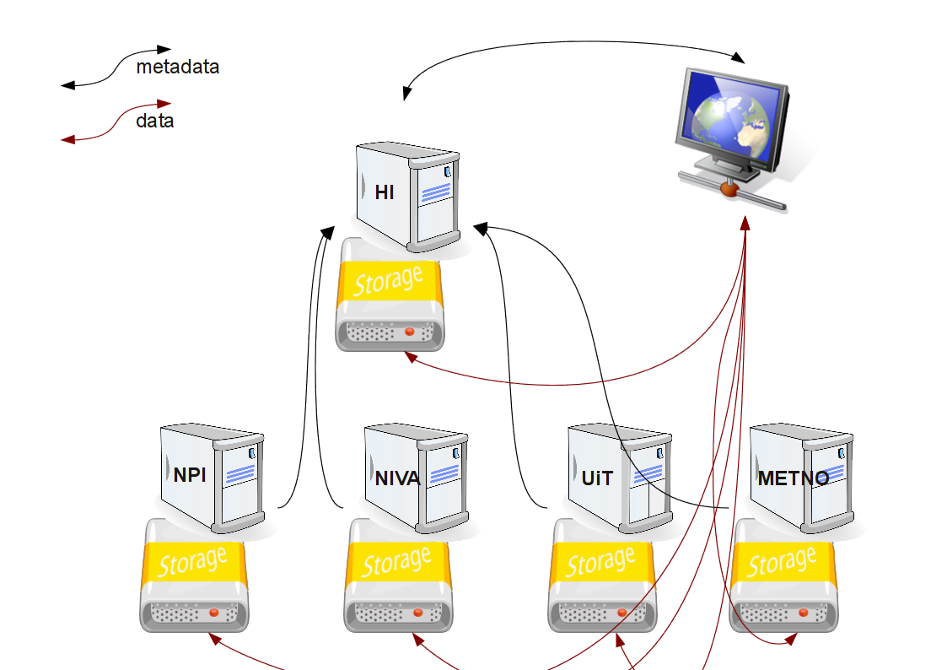Figure 1: Physical outline of the NMDC system. The central node at Institute of Marine Research harvest metadata from the supporting nodes. Supporting nodes maintain metadata and data as well as interfaces to the metadata and data. Metadata are served to users through the central node, data are served directly from the supporting nodes, transformations are done primarily at the central node utilising the machine interfaces to data-

Functional Components
The main functional components of NMDC is outlined in Figure 2.
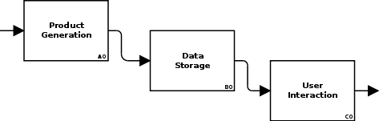Figure 2: Main functional components of NMDC.
Each of the components identified in Figure 2 can be a physical or a virtual unit.

Product Generation

Purpose
The product generation component collects data from a number of sources and transforms data into properly documented products according to the agreed file format and metadata standards. Utilisation of agreed documentation standards minimise end user efforts and subsequent need for post processing prior to delivery to the end user. When products are generated, the product generation component submits these to the data storage component.
The product generation component hosted by a producer is unique to that user.

Subcomponents
The main functional components of product generation component is outlined in Figure 3.
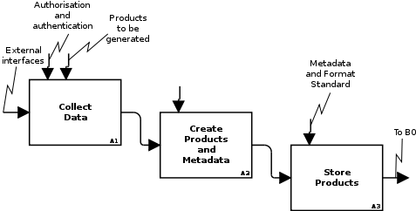Figure 3: The main elements of the data production component.
Each of the functional components identified in Figure 3 can be further broken down, but the production component is to a large degree black boxes as these are pre-existing elements of each production units infrastructure. NMDC is not altering existing infrastructure, but focus on linking the storage components of each production unit in a manner that allows users to have a single point of entry to the NMDC system. The single point of entry will allow users to search for data and redirect the user to the actual production unit which contains the product of interest.

Interfaces
Internal interfaces within the product generation component are defined by each production centre based upon existing infrastructure. There are no NMDC requirements directly on the production component. NMDC requirements that may affect the production component are requirements imposed on the data storage component in order to establish a single point of entry for NMDC users.

Open issues
Potentially NMDC may require some changes in the production component to be able to establish a common discovery and higher order services across the physically distributed production components. However, no such requirements are currently known.

Data Storage

Purpose
The data storage component receives products from the product generation component and performs compliance checks before products are routed into the storage systems for stable storage.
The data storage component is responsible for both online data repositories serving the end users through the data distribution component, and for the long term archival and preservation of the products handled. This component is also responsible for proper metadata management and for the linking of metadata and products. It also supports user requests from the web portal.
Each dataset handled by the data storage component should have a unique id. This is should support identification of datasets even if they are moved within the production unit. The unique id could be e.g. a DOI or an id determined and maintained by the production unit itself.
A data repository component may support several production components.

Subcomponents

Overview
The main functional components of the data repository is outlined in Figure 4.
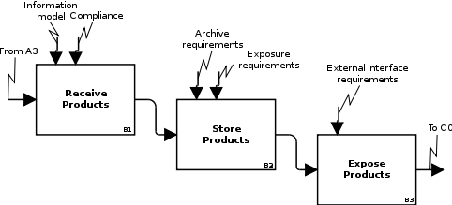Figure 4: The main functional components of the data repository.
Each of the functional components identified in Figure 4 can be further broken down.

Receive products
The first time a dataset is registered within the data management system it has to be properly configured and documented. Updates to the dataset will usually affect the timeline of the dataset. NMDC is not an operational system. In the initial phase datasets are likely to be defined and uploaded in bulk, but later a continuous stream of products may be expected. Large re-analysis tasks are likely to impose bulk uploads/changes to datasets throughout the system lifetime.
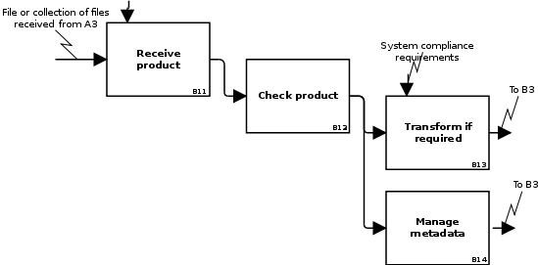Figure 5: Generic model for reception of NMDC products to the data storage component.

Store products
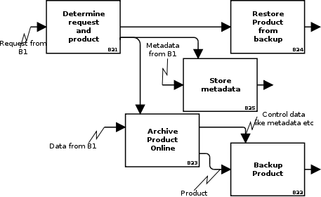Figure 6: Management of products on storage systems.

Expose metadata and products
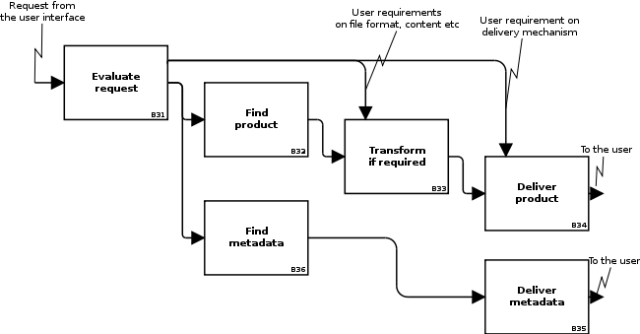Figure 7: Delivery of products to the user depends on the user input, stated as requirements on delivery format/mechanism and content.

Interfaces
The data storage component shall support both internal and external operations. Internal operations can be of two types. They may be internal to the production unit and internal to the NMDC system. Internal operations of the production unit is not covered here, only issues that may affect NMDCs ability to deliver functionality to NMDC users. Internal operations affecting NMDCs ability to deliver functionality may be issues encountered when a NMDC user requests a combined dataset containing data stored physically at different NMDC production units. External operations are e.g. direct data access by external users.
The infrastructure of the production units contributing to the NMDC system vary. Many different file formats and underlying systems are in use. The main issue for NMDC is that the number of file formats that the NMDC system and external users has to relate to must be as few as possible. And they must contain enough information for higher order services to be established. The file formats chosen should support users analysing the information using computers, not only users browsing images. The latter is expected to be covered by utilisation of OGC WMS.
Essentially users need to access both raster (or grid) oriented data and vector information and NMDC must support these data types. In the first phase of NMDC it has become evident that the different systems contributing to NMDC have different experience with the user community concerning requested file formats.
The target audience of NMDC is the scientific community and within this NetCDF/CF has become the dominant file format for raster information in recent years. It is used by various international projects like MyOcean, GHRSST, Damocles as well as for numerical modelling of both the ocean and the atmosphere. NetCDF/CF is highly versatile and gains increased footprint in scientific communities. Furthermore it is suitable for long term data preservation as it comes with a documentation model. Another benefit is the tight integration with the OpENDAP protocolwhich allows data to be addressed as data streams allowing cost effective services to be established on top of the actual data. Through the usage of aggregation (in e.g. THREDDS) the data access is enabled as a an abstract layer on top of physical files simplifying time series. Concerning vector formats the scientific community is less unified but in projects like CryoClim focusing on scientists there has been a demand for ESRI Shapefiles as many applications support this format.
NMDC users should be able to get data in the following formats depending on the nature of the data and specific user needs. The following file formats are relevant for the user community of NMDC:
- NetCDF/CF following the NetCDF Attribute Convention for Dataset Discovery (NACDD)
- ESRI Shapefile
- Ocean Data View exchange format
- Spreadsheets
The data storage component at each production unit should be able to deliver these file formats preferably through transformations to avoid duplicating the information. The file formats to be delivered to users are implemented as data transformation services when not delivered directly from the underlying system.
Concerning delivery protocols for data, this can also be divided according to the purpose. Any number of protocols (e.g. FTP, HTTP, OpeNDAP, OGC WCS, OGC WFS) can be supported for each production unit, but the protocol to use to establish unified functionality across the physically distributed production units has to be identified. Protocols that support subsetting etc (e.g. OpeNDAP, OGC WCS, OGC WFS) are preferred in order to be able to offer users transformation functionality. Concerning NMDC, OpeNDAP seems to be least costly in the beginning for serving file based data repositories. Data repositories relying on relation database technologies would require RESTful interfaces that could be utilised by the system. These systems must as a minimum deliver the agreed file formats.
Concerning metadata, NMDC should use ISO19115 internally. For scientific keywords GCMD DIF Science Keywords should be used. Internally within NMDC, metadata should be synchronised using straightforward HTTP, OAI-PMH or OGC CSW.

Open issues
The level of unified functionality between the physical distributed production units is still to be determined. First priority is given to establishing a unified discovery service. Essentially this implies that a common standard for metadata must be established as well as a common mechanism for exchange of metadata. The simplest method for exchanging metadata is HTTP or FTP. Details on how to identify deleted /obsolete datasets needs to be determined. Using e.g. OAI-PMH this is handled.
Concerning unified services that handles multiple datasets distributed physically (visualisation and/or transformation), this can be handled using OpeNDAP but the metadata granularity has to be discussed. The problem is the relation between discovery and use metadata as well as addressing individual files. using OpeNDAP, this can be solved using aggregated datasets covering several physical files if THREDDS Data Server is used to serve files.
Concerning NetCDF, the emerging NetCDF version is NetCDF4, but this is probably too early to use towards the user community although it has strong benefit over the old version. NetCDF4 supports inline data compression, compound data types and groups, contrary to the classic version of NetCDF. The use of NetCDF4 should be continuously revisited during the project.
The granularity of metadata is still an open issue. Details should be discussed in more detail for especially for data stored in databases where viewpoints may be different.

User Interaction

Purpose
The user interaction component includes human and machine interfaces towards end users and international data management systems. It covers interfaces to metadata as well as products and potential transformations required by users prior to data delivery. Both ad hoc users and regular users subscribing to data should be supported.
The user interaction component is on a physical component that relates to many data storage components. However, data and information may be directly served from each data storage component as well although full integration of all data storage components are not expected except through the user interaction component.

Subcomponents

Overview
The main functional components of the data repository is outlined in Figure 8.
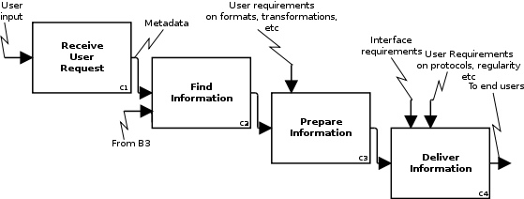Figure 8: The main functional components of the distribution component.
Each of the functional components identified in Figure 8 can be further broken down. Provided NMDC establishes a common discovery, C1 and C2 are handled by the portal solution and accompanying systems. C3 and C4 is a mix between functionality in the portal and in the distributed storage systems,

Receive user request
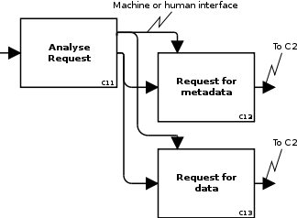Figure 9: Functional components handling user requests.

Find information
This functionality relies on proper documentation of all datasets and synchronisation of metadata.
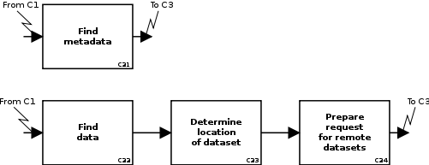Figure 10: Functional components determining the nature of a request in a distributed system.

Prepare information
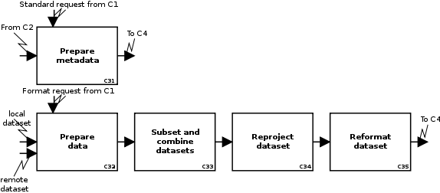Figure 11: Functional components preparing data for the end user. Included in this view is simple transformation services, but no high level filtering of data.
Preparation of the datasets will rely on transformation functionality implemented at each production sites data storage. It could be done through a central transformation service as well. Basically this functionality relies on synchronised metadata describing the services (visualisation, access, transformation etc) available for each dataset.

Deliver information
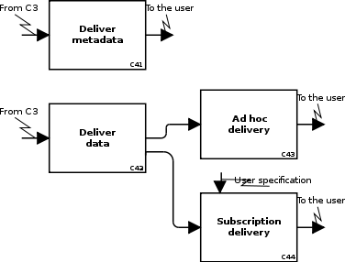Figure 12: Functional components determining delivery of data to NMDC users.

Interfaces
Visualisation of products are handled using OGC WMS.
Access to products are handled using HTTP, OpeNDAP and OGC WCS preferably through a THREDDS Data Server as this allows aggregation of products. This has proven a cost effective way to enable visualisation, access and transformation in a physically distributed system and has been used by e.g. MyOcean. In addition to the OGC WCS, OGC WFS should also be supported for the relevant datasets.
Transformation of products may be handled using a number of tools. METNO will use FIMEX (https://wiki.met.no/fimex/). For this to work in a distributed manner, transformation tools need a URL-based interface (e.g. OGC WPS, but it may be simpler like in MyOcean). METNO have implemented a transformation service based upon FIMEX for MyOcean and adapted this to the MyOcean Information System Gateway. If the distributed data storage of NMDC is served through THREDDS and datasets are aggregated, FIMEX may offer transformation services directly from a centralised portal for products of interest. Concerning unifying datasets across the physically distributed storage components of NMDC, this is a cost effective and fast solution.
Currently OGC WCS and WFS are considered non-Restful web services. Recent development within the OGC indicates that OGC standards will have Restful interfaces and that the INSPIRE requirements will refer to these as well as the SOAP interfaces.

Open issues
Following the discussions at the project progress meeting in Tromsø in June 2011, the user interaction component will be physically centralised in the sense that the web portal runs at one location in the beginning, but relies on interfaces implemented at each production unit to support users with discovery, access and in the end transformation of products.
The level of functionality served to NMDC users is still an open question and needs to be defined before further decisions on interfaces. As mentioned above, it starts with unified discovery, but according to the project proposal transformation services across datasets should be attempted.

Defined by Wikipedia as “data storage technology that guarantees atomicity for any given write operation and allows software to be written that is robust against some hardware and power failures”.
This is handled using database interfaces for data stored in databases.
Comma Separated Files in the simplest form, or OpenDocumentFormat and/or Microsoft formats.
Initially the core elements are used,
For small data repositories with few changes.
For quick win and light weight implementation.
Not all partners support OGC WCS or OAI-PMH yet, thus the simple and fast solution may be to provide information in the correct XML-representation and transfer this in a regular manner using HTTP or FTP to achieve the basic functionality. this may however not be a sustainable solution.
Synchronisation in a wide sense.
Personal communication with Chris Little (UKMO) co-chair of the OGC MetOcean Working Groupd, Septe 2011.

